IP Camera

Smartphone -ready colour night/day

network camera with pan, tilt and zoom
DYN-627
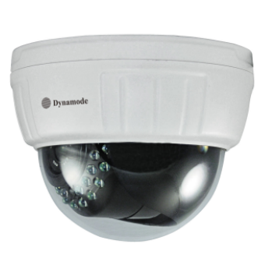

Specification
- Product type：IP camera
- Operation system：Embedded operating system
- Web protocol：TCP/IP, UDP/IP, HTTP, SMTP, FTP, DHCP, DDNS, UPNP, NTP, RTSP, ONVIF
- LAN port：10Base-T/100Base-TX
- Wifi：802.11 b/g/n
- Resolution：720P, 640*360, 320*180
- Compression mode：H.264/M-JPEG
- Max frame rate：30fps
- Lens：f=4mm, F=1.2
- Min. illumination：IR on, 0 Lux
- Electronic shutter：1/50s(1/60s)-1/100,000 s
- SNR：48db
- Safety performance：Three levels of user rights
- Install mode：ceiling-mounted
- Other performance：PC software,support for Microsoft Windows 98/2000/XP/Vista/Windows 7/Mac OS,And the Internet Explorer6.1 and above version or browser compatibility, Firefox, etc., provide iSmartViewPro client software
- Power supply：DC 12V
- Sensor：CMOS Sensor
- IP camera performance：Support video control, Two-way voice talkback, motion detection, external alarm(sends information to alarm the server by Email, FTP);Manufacturers provide free DDNS, and has been written into equipment; 10pcs IR LEDs, 8meters effectively; Platform level angle 350°, 120 °vertical angle; automatically control through the photoresistor;
- Audio input：None
- Audio output：None
- Alarm in：None
- Alarm out：None
- Power consumption：Power<8W
- Body size：130*130*100mm
- Product weight：0.36kg
- Environment temperature：-10℃--50℃℃
- Environment humidity：below 85% RH

